Automated EDA Report: Bank data Project
Generated: 2025-11-25 19:46:21

1. Dataset Summary
Original shape: (230484, 22)
After cleaning shape: (230484, 22)
Duplicates dropped: 0

2. Detected Column Types
Numeric (9): Age, Annual_Income, Loan_Amount, Credit_Score, EMI_Amount, Mobile_Number, Account_Balance, Interest_Rate, Disbursed_Amount
Categorical (4): Gender, Loan_Status, Loan_Term, Loan_Repayment_Status
Datetime (1): Loan_Approval_Date
Other (8): Customer_ID, Customer_Name, Occupation, City, State, Loan_Type, Bank_Branch, Branch_Manager

3. Missing Values & Imputation
Column | Missing Count | Missing % | Imputed With
Customer_ID | 0 | 0.0
Customer_Name | 0 | 0.0
Age | 0 | 0.0
Gender | 0 | 0.0
Occupation | 0 | 0.0
Annual_Income | 0 | 0.0
City | 0 | 0.0
State | 0 | 0.0
Loan_Type | 0 | 0.0
Loan_Amount | 0 | 0.0
Loan_Status | 0 | 0.0
Credit_Score | 0 | 0.0
EMI_Amount | 0 | 0.0
Loan_Term | 0 | 0.0
Loan_Approval_Date | 40491 | 17.57 | ffill_bfill_or_placeholder
Mobile_Number | 1610 | 0.7 | numeric_median
Bank_Branch | 0 | 0.0
Account_Balance | 0 | 0.0
Interest_Rate | 0 | 0.0
Loan_Repayment_Status | 0 | 0.0
Disbursed_Amount | 0 | 0.0
Branch_Manager | 0 | 0.0

4. Univariate Analysis (highlights)

Customer_ID
Top categories:
CUST00001: 1
CUST153621: 1
CUST153651: 1
CUST153652: 1
CUST153653: 1
CUST153654: 1
CUST153655: 1
CUST153656: 1
CUST153657: 1
CUST153658: 1
Histogram:
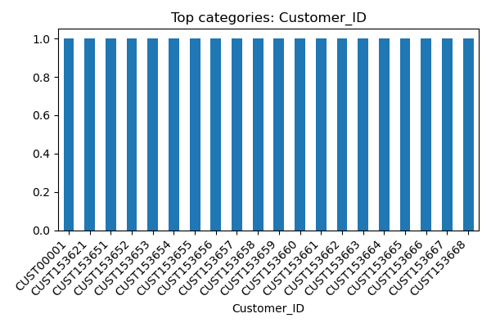

Customer_Name
Top categories:
PURAB DHAR: 12
AAYUSH BUCH: 12
ALISHA SAMPATH: 12
MADHAV KALA: 12
DIVYANSH DARA: 12
RAGHAV DUGAR: 11
MISHA KALA: 11
AARNA BUCH: 11
AAYUSH KALA: 11
MEHUL SEKHON: 10
Histogram:
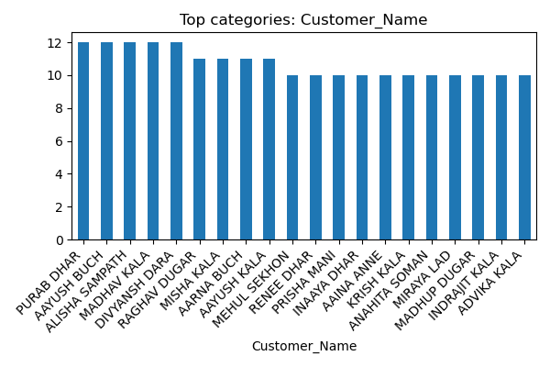

Age
Numeric column — count=230484, mean=44.011, std=15.286, min=18.0, 25%=31.0, 50%=44.0, 75%=57.0, max=70.0
Histogram:
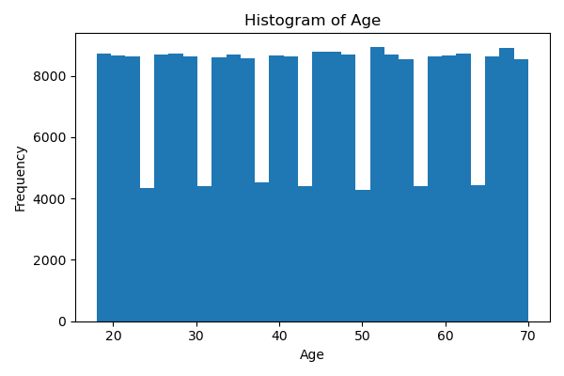
Boxplot:
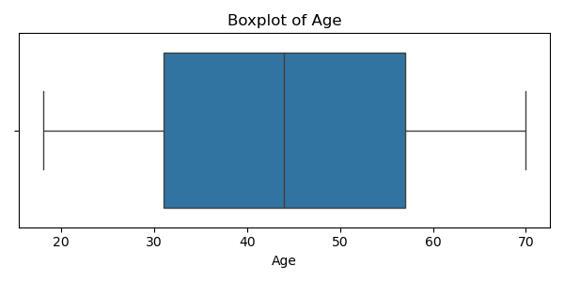

Gender
Top categories:
MALE: 77146
FEMALE: 76744
OTHER: 76594
Histogram:
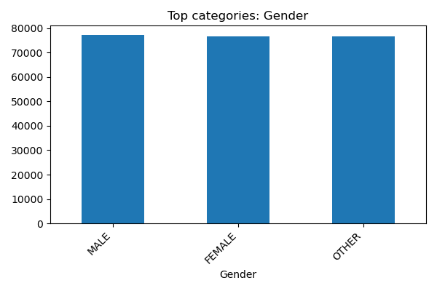

Occupation
Top categories:
SELF-EMPLOYED: 34676
RETIRED: 34512
STUDENT: 34495
SALARIED: 34439
UNEMPLOYED: 34421
STUDETN: 2047
REITRED: 1966
RETIRDE: 1957
RETRIED: 1955
ERTIRED: 1954
Histogram:
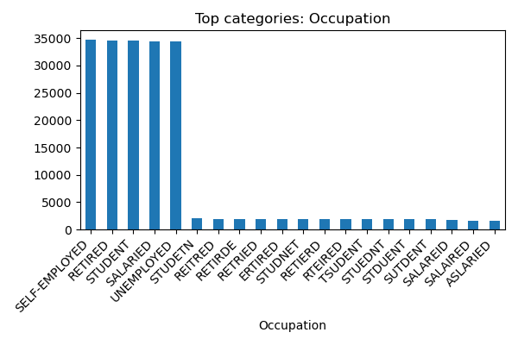

Annual_Income
Numeric column — count=230484, mean=1348861.084, std=664284.376, min=200004.0, 25%=772936.0, 50%=1346870.5, 75%=1924250.0, max=2499999.0
Histogram:
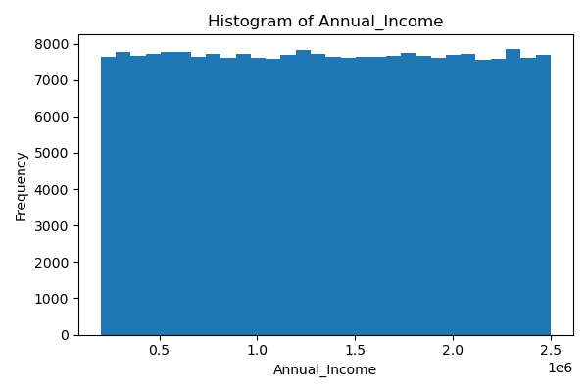
Boxplot:
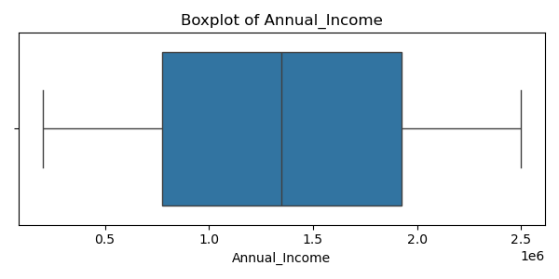

City
Top categories:
GHAZIABAD: 1071
AURANGABAD: 1042
ALLAHABAD: 613
PUDUKKOTTAI: 609
NARASARAOPET: 608
TADEPALLIGUDEM: 607
VELLORE: 605
CUTTACK: 605
BIDHANNAGAR: 603
HUBLI–DHARWAD: 603
Histogram:
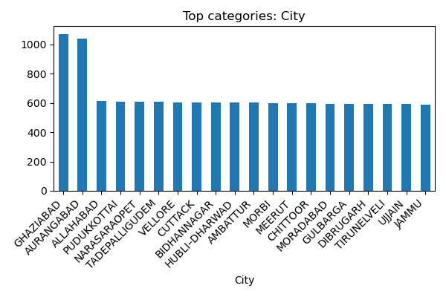

State
Top categories:
UTTAR PRADESH: 21863
MAHARASHTRA: 21862
ANDHRA PRADESH: 21722
KARNATAKA: 21706
DELHI: 21662
RAJASTHAN: 21621
WEST BENGAL: 21611
TAMIL NADU: 21297
DELIH: 1847
EDLHI: 1841
Histogram:
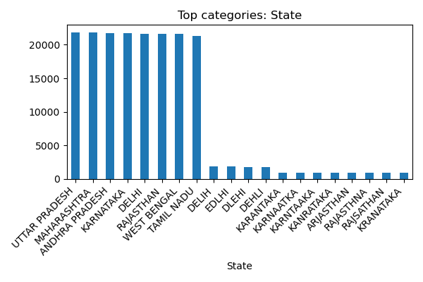

Loan_Type
Top categories:
CAR LOAN: 34778
HOME LOAN: 34772
EDUCATION LOAN: 34583
GOLD LOAN: 34436
PERSONAL LOAN: 34387
CRA LOAN: 1697
CA RLOAN: 1687
CARL OAN: 1666
CAR OLAN: 1665
CAR LAON: 1641
Histogram:
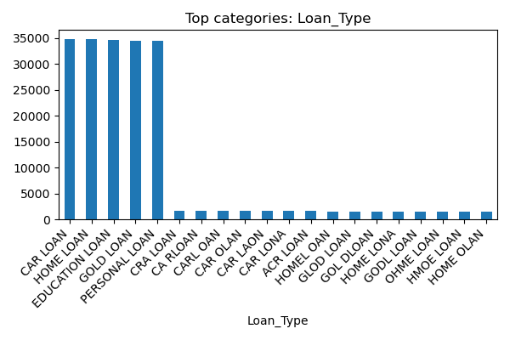

Loan_Amount
Numeric column — count=230484, mean=1097855.983, std=1079367.920, min=50010.0, 25%=429510.0, 50%=741555.0, 75%=1259158.75, max=4999960.0
Histogram:
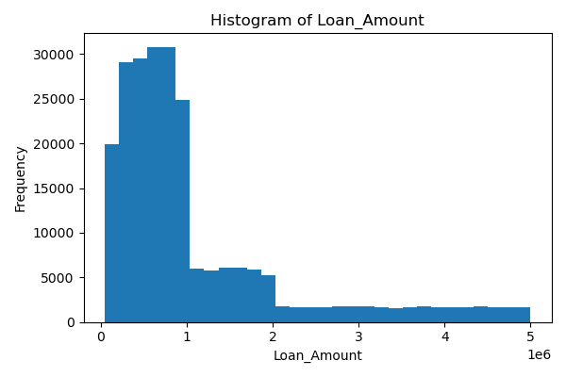
Boxplot:
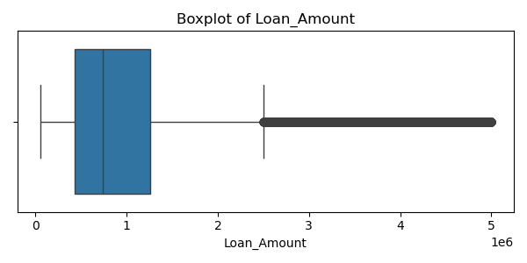

Loan_Status
Top categories:
CLOSED: 76949
ACTIVE: 76832
DEFAULT: 76703
Histogram:
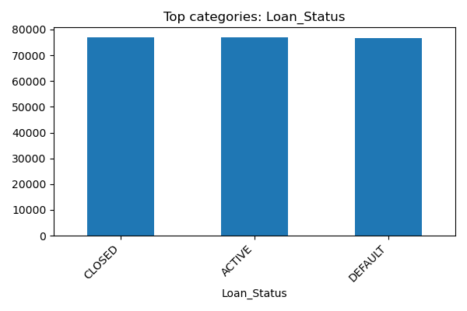

Credit_Score
Numeric column — count=230484, mean=575.140, std=158.923, min=300.0, 25%=438.0, 50%=575.0, 75%=713.0, max=850.0
Histogram:
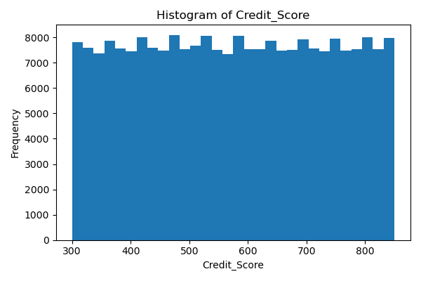
Boxplot:
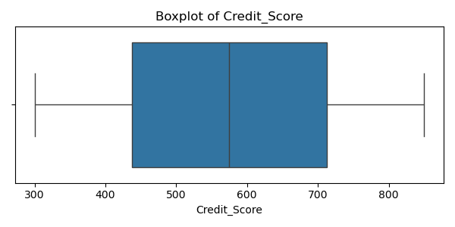

EMI_Amount
Numeric column — count=230484, mean=25211.526, std=17742.123, min=1233.5, 25%=11631.5075, 50%=20564.58, 75%=34967.3375, max=90215.92
Histogram:
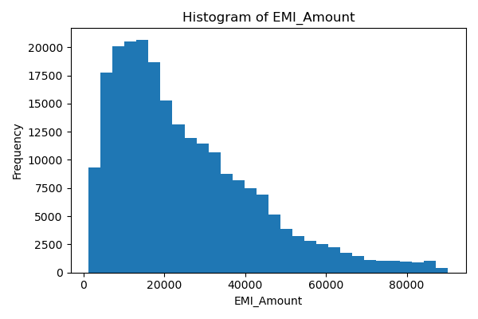
Boxplot:
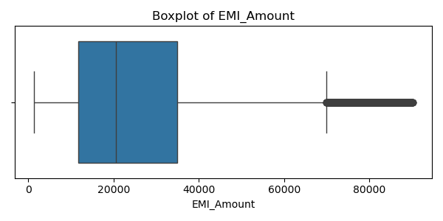

Loan_Term
Top categories:
36: 38266
72: 27118
60: 26902
12: 26858
24: 26775
48: 23005
84: 15199
240: 9376
360: 9310
120: 9297
Histogram:
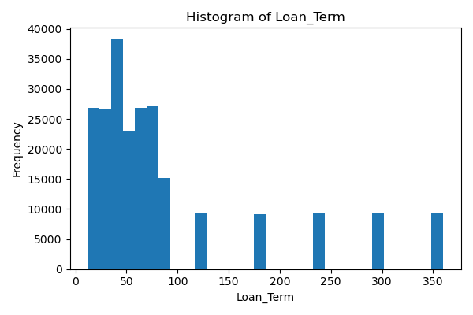
Boxplot:
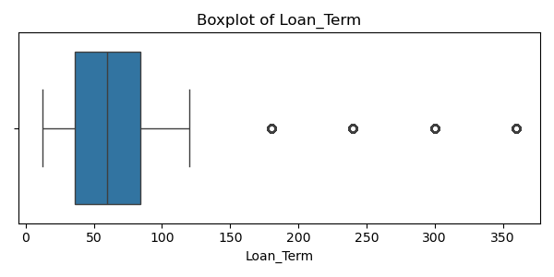

Loan_Approval_Date
Top categories:
2020-11-20 00:00:00: 170
2022-11-21 00:00:00: 162
2022-04-09 00:00:00: 162
2021-04-30 00:00:00: 161
2023-01-20 00:00:00: 159
2022-05-13 00:00:00: 158
2023-07-20 00:00:00: 156
2022-01-20 00:00:00: 156
2022-10-24 00:00:00: 156
2022-12-30 00:00:00: 155
Histogram:
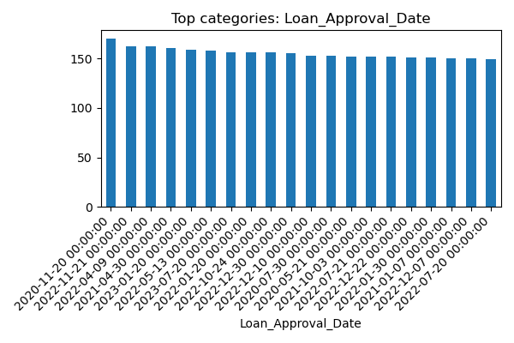

Mobile_Number
Numeric column — count=230484, mean=296793510850.174, std=423461297445.417, min=5761.0, 25%=3782490390.25, 50%=7526118116.0, 75%=912000000000.0, max=992000000000.0
Histogram:
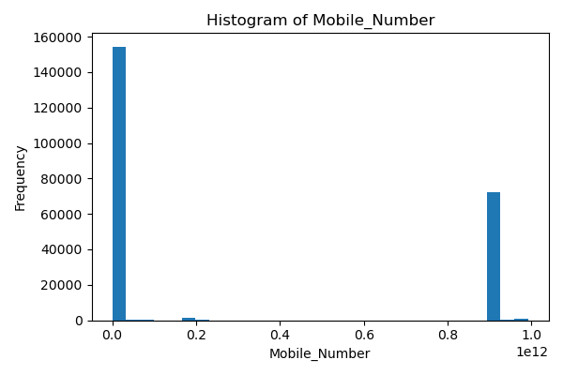
Boxplot:
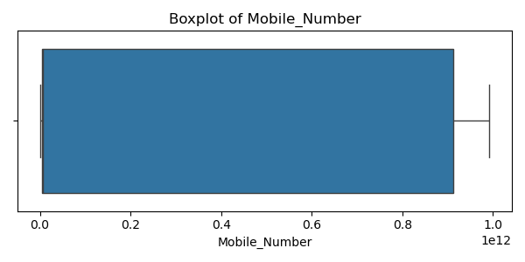

Bank_Branch
Top categories:
MUMBAI BRANCH: 43496
DELHI BRANCH: 43404
KOLKATA BRANCH: 43330
BANGALORE BRANCH: 42817
DELHI BRACNH: 1319
DELHI BARNCH: 1316
DELH IBRANCH: 1315
DELHIB RANCH: 1310
MUMBAIB RANCH: 1302
DELHI BRANHC: 1283
Histogram:
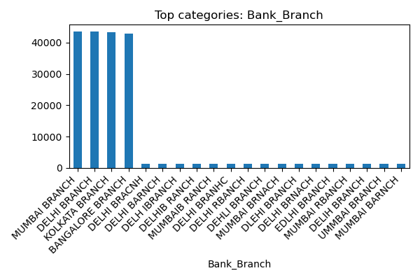

Account_Balance
Numeric column — count=230484, mean=252676.151, std=143048.509, min=5002.0, 25%=128298.5, 50%=252734.5, 75%=376612.0, max=499995.0
Histogram:
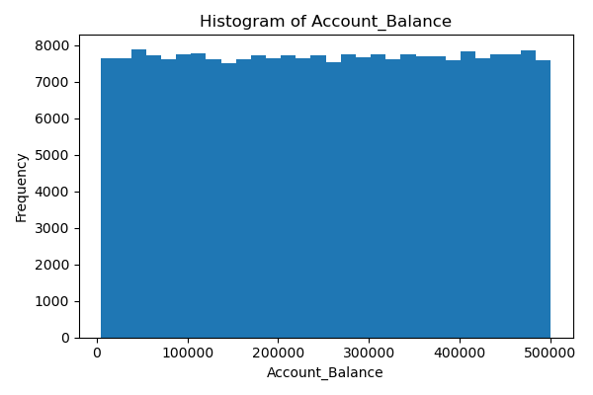
Boxplot:
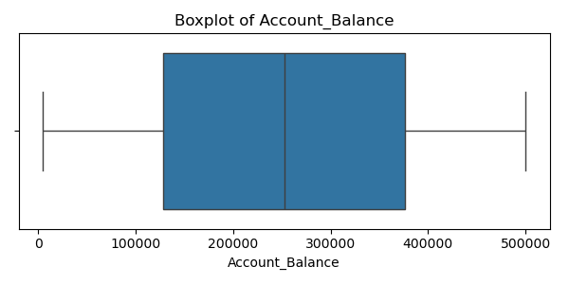

Interest_Rate
Numeric column — count=230484, mean=11.494, std=2.020, min=8.000015486, 25%=9.7455986755, 50%=11.487193155, 75%=13.2393628375, max=14.99996487
Histogram:
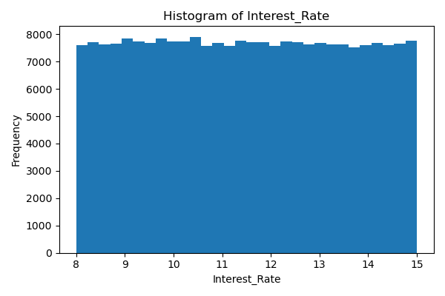
Boxplot:
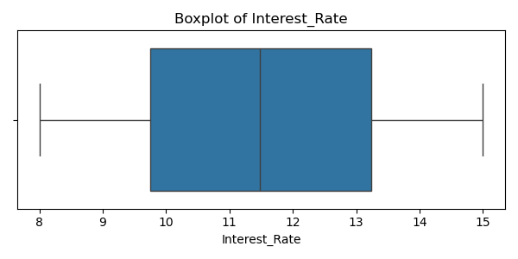

Loan_Repayment_Status
Top categories:
COMPLETED: 77227
PENDING: 76641
DEFERRED: 76616
Histogram:
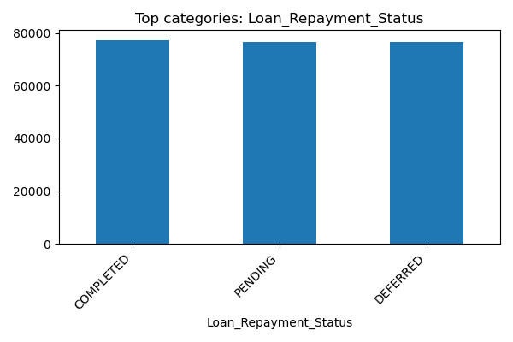

Disbursed_Amount
Numeric column — count=230484, mean=1097855.983, std=1079367.920, min=50010.0, 25%=429510.0, 50%=741555.0, 75%=1259158.75, max=4999960.0
Histogram:
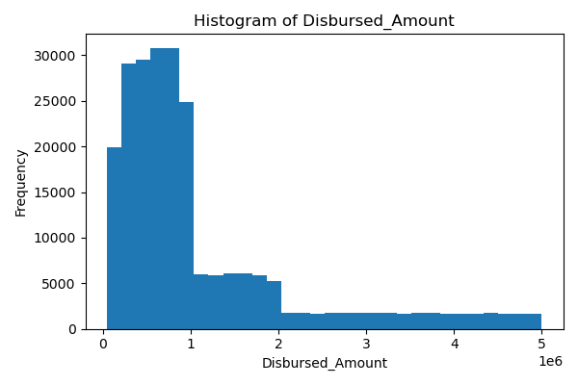
Boxplot:
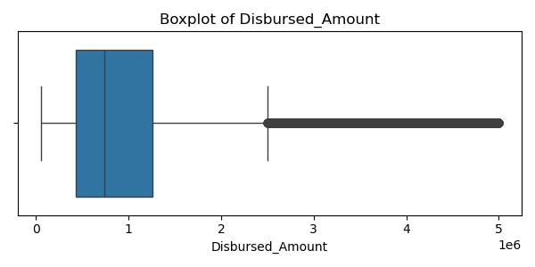

Branch_Manager
Top categories:
HUNAR KALA: 13
SAMAIRA DARA: 12
YASMIN KALA: 12
UTHKARSH KALA: 11
EMIR MADAN: 11
EHSAAN DHAR: 11
GOKUL KALA: 10
VANYA BARAD: 10
DHARMAJAN KALA: 10
AYESHA KALA: 10
Histogram:
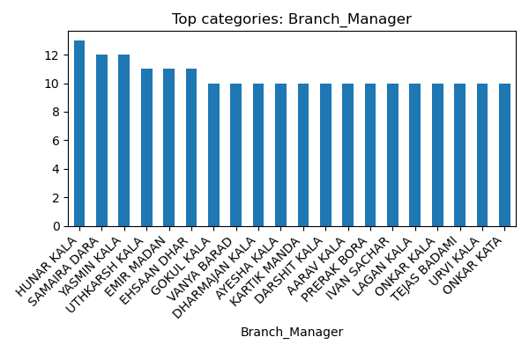

5. Bivariate Analysis (highlights)

Numeric Correlation Matrix
Pearson correlation matrix for numeric columns
Plot:
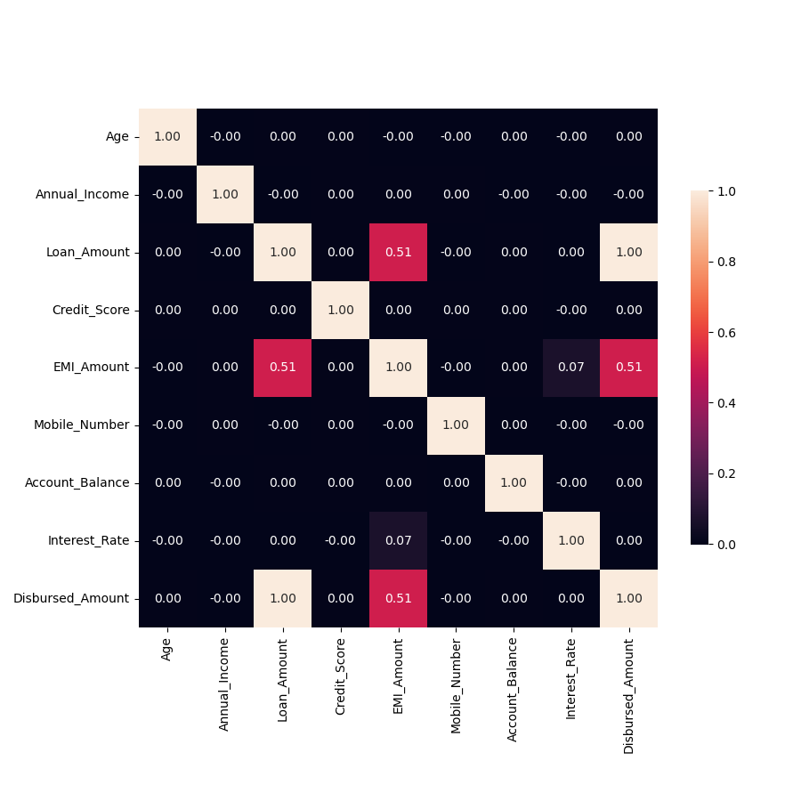

Loan_Amount vs Disbursed_Amount
Scatter: correlation 1.000
Plot:
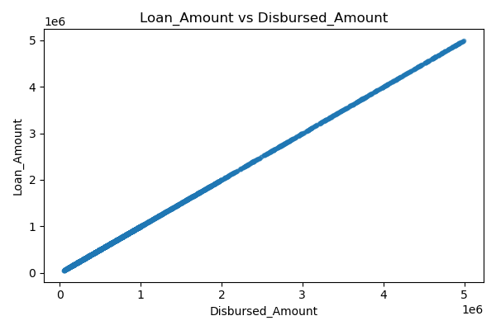

EMI_Amount vs Disbursed_Amount
Scatter: correlation 0.512
Plot:
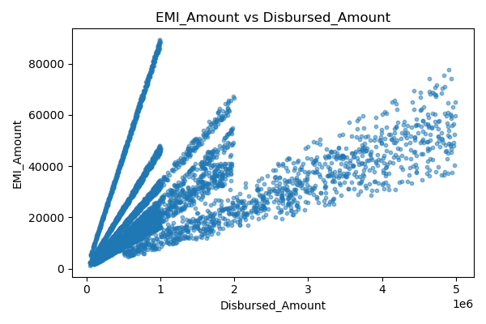

Interest_Rate vs EMI_Amount
Scatter: correlation 0.071
Plot:
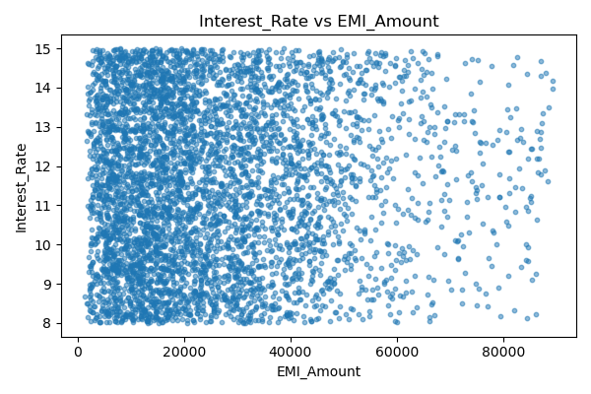

Credit_Score vs Account_Balance
Scatter: correlation 0.004
Plot:
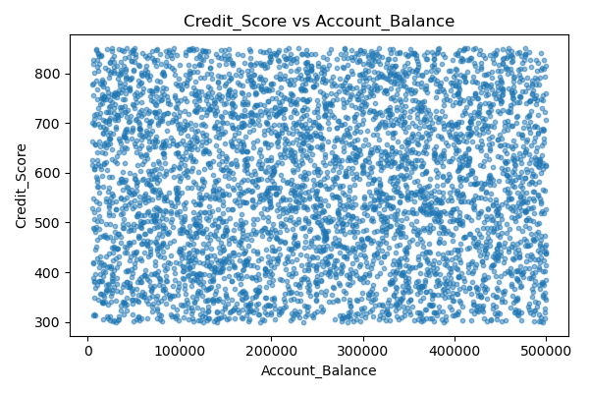

Account_Balance vs EMI_Amount
Scatter: correlation 0.003
Plot:
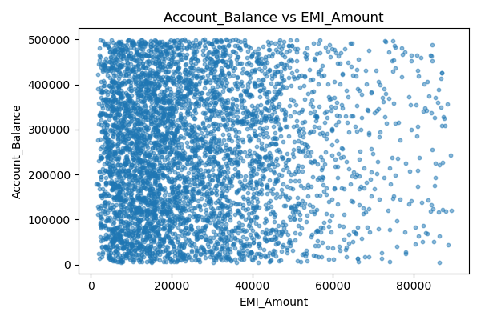

Age vs Mobile_Number
Scatter: correlation -0.003
Plot:
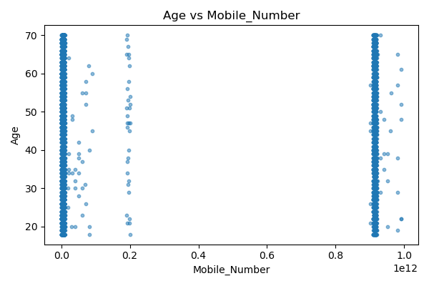

Age by Gender
Group stats for numeric column 'Age' by category 'Gender':
Gender count mean median std
MALE 77146 44.031602 44.0 15.263009
FEMALE 76744 43.968375 44.0 15.307909
OTHER 76594 44.032940 44.0 15.287730
Plot:
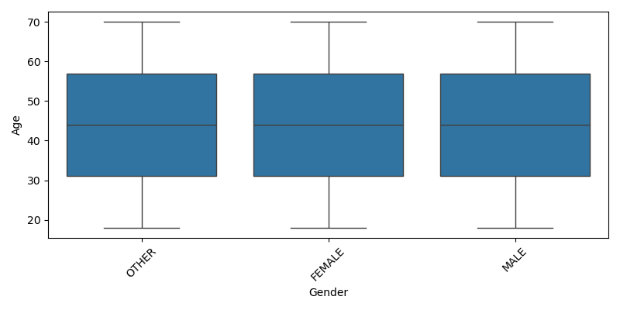

Annual_Income by Gender
Group stats for numeric column 'Annual_Income' by category 'Gender':
Gender count mean median std
MALE 77146 1.346595e+06 1341211.5 664456.080438
FEMALE 76744 1.352774e+06 1356744.5 662678.647358
OTHER 76594 1.347222e+06 1342353.0 665708.024470
Plot:
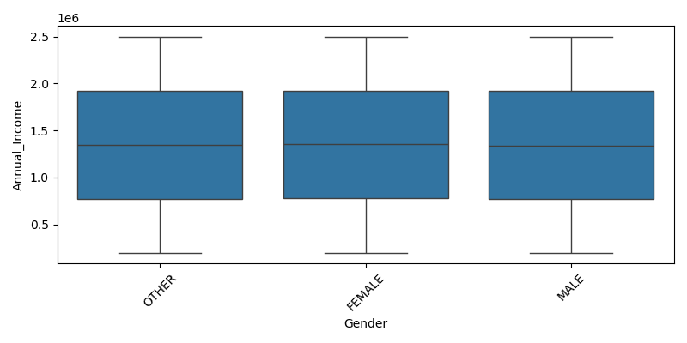

Loan_Amount by Gender
Group stats for numeric column 'Loan_Amount' by category 'Gender':
Gender count mean median std
MALE 77146 1.097377e+06 739567.5 1.082624e+06
FEMALE 76744 1.099457e+06 743993.0 1.078291e+06
OTHER 76594 1.096734e+06 741157.0 1.077172e+06
Plot:
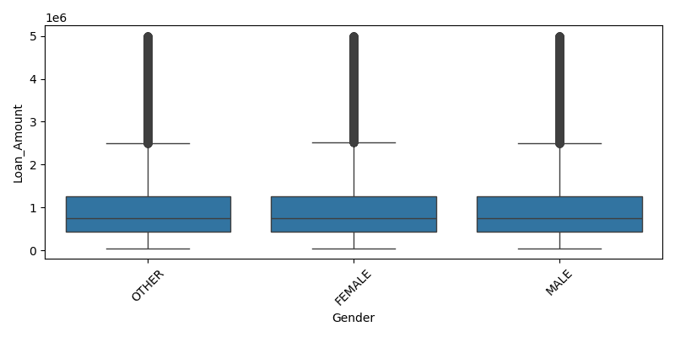

Credit_Score by Gender
Group stats for numeric column 'Credit_Score' by category 'Gender':
Gender count mean median std
MALE 77146 574.979532 574.0 159.335456
FEMALE 76744 574.866843 575.0 158.734502
OTHER 76594 575.574627 576.0 158.695849
Plot:
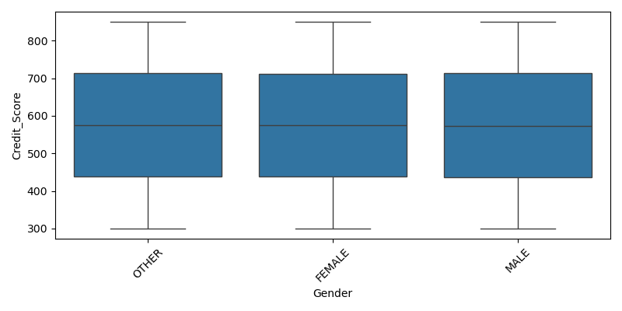

EMI_Amount by Gender
Group stats for numeric column 'EMI_Amount' by category 'Gender':
Gender count mean median std
MALE 77146 25151.538374 20479.885 17726.897907
FEMALE 76744 25287.503630 20671.345 17744.762144
OTHER 76594 25195.820368 20549.695 17754.760973
Plot:
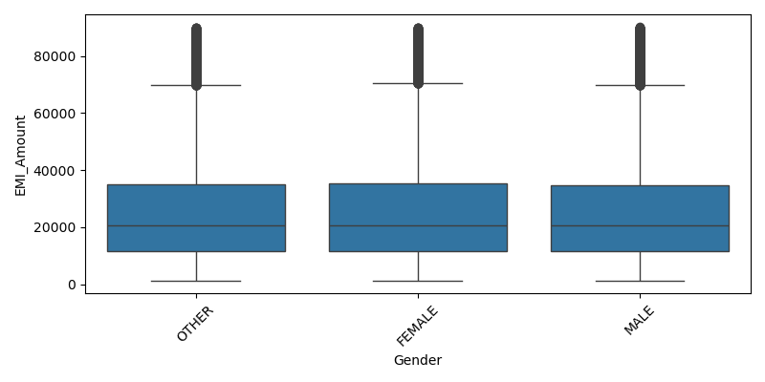

Mobile_Number by Gender
Group stats for numeric column 'Mobile_Number' by category 'Gender':
Gender count mean median std
MALE 77146 2.979274e+11 7526118116.0 4.238299e+11
FEMALE 76744 2.970138e+11 7526118116.0 4.235863e+11
OTHER 76594 2.954307e+11 7526118116.0 4.229661e+11
Plot:
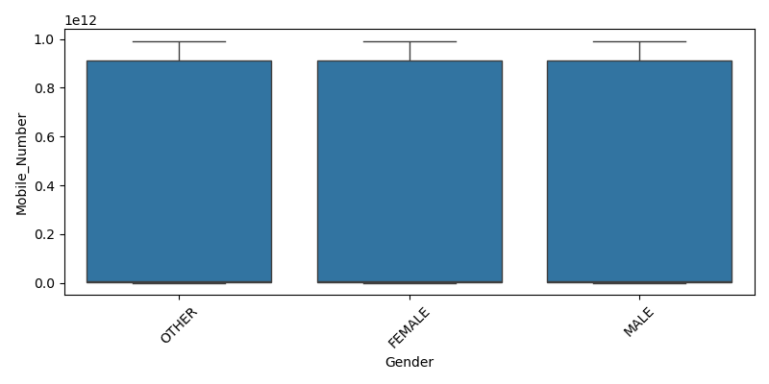

Age by Loan_Status
Group stats for numeric column 'Age' by category 'Loan_Status':
Loan_Status count mean median std
CLOSED 76949 44.008837 44.0 15.269655
ACTIVE 76832 44.022569 44.0 15.288639
DEFAULT 76703 44.001564 44.0 15.300378
Plot:
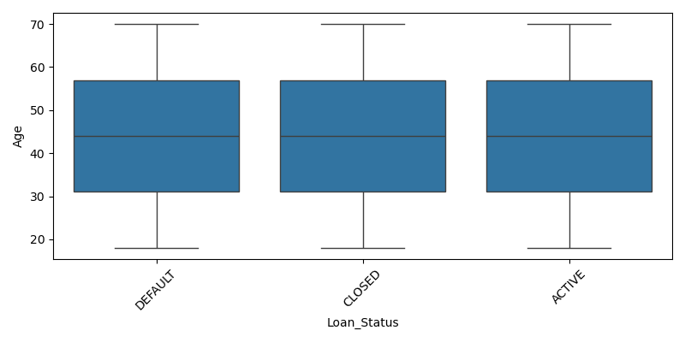

Annual_Income by Loan_Status
Group stats for numeric column 'Annual_Income' by category 'Loan_Status':
Loan_Status count mean median std
CLOSED 76949 1.345704e+06 1339023.0 664004.050873
ACTIVE 76832 1.351082e+06 1355815.5 664783.675669
DEFAULT 76703 1.349804e+06 1347200.0 664061.920769
Plot:
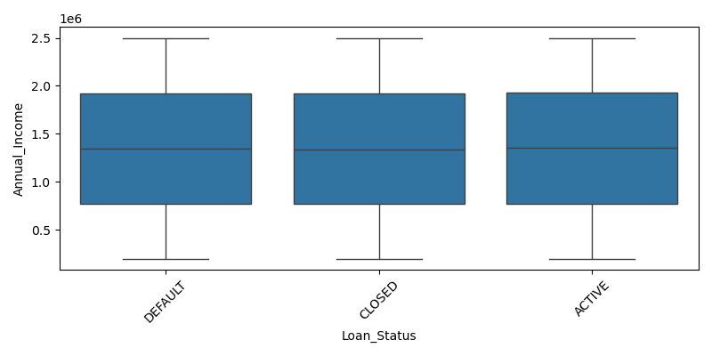

Loan_Amount by Loan_Status
Group stats for numeric column 'Loan_Amount' by category 'Loan_Status':
Loan_Status count mean median std
CLOSED 76949 1.091235e+06 740314.0 1.072362e+06
ACTIVE 76832 1.102192e+06 743819.0 1.083710e+06
DEFAULT 76703 1.100154e+06 740856.0 1.081994e+06
Plot:
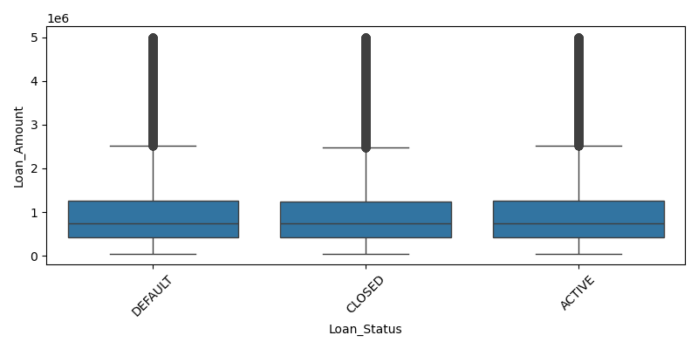

Credit_Score by Loan_Status
Group stats for numeric column 'Credit_Score' by category 'Loan_Status':
Loan_Status count mean median std
CLOSED 76949 575.632055 576.0 159.409014
ACTIVE 76832 575.578691 576.0 158.574178
DEFAULT 76703 574.206250 574.0 158.780662
Plot:
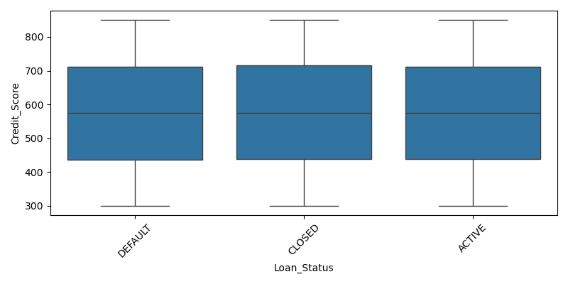

EMI_Amount by Loan_Status
Group stats for numeric column 'EMI_Amount' by category 'Loan_Status':
Loan_Status count mean median std
CLOSED 76949 25185.065937 20476.18 17782.195096
ACTIVE 76832 25232.796500 20657.60 17687.987223
DEFAULT 76703 25216.765495 20560.52 17756.212659
Plot:
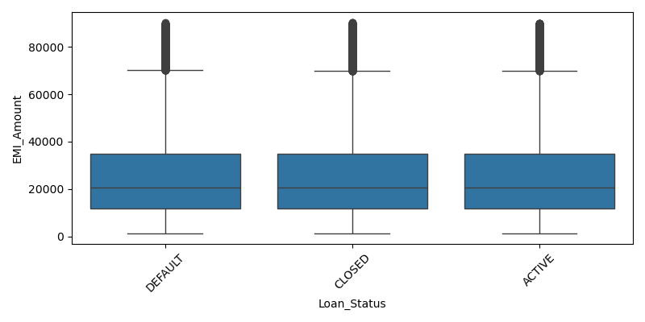

Mobile_Number by Loan_Status
Group stats for numeric column 'Mobile_Number' by category 'Loan_Status':
Loan_Status count mean median std
CLOSED 76949 2.959932e+11 7526118116.0 4.231281e+11
ACTIVE 76832 2.962092e+11 7526118116.0 4.232934e+11
DEFAULT 76703 2.981817e+11 7526118116.0 4.239653e+11
Plot:
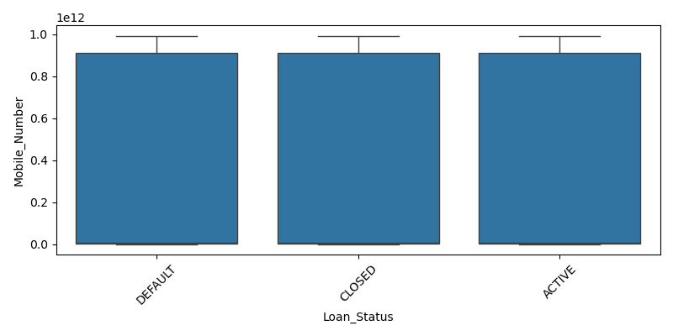

Age by Loan_Term
Group stats for numeric column 'Age' by category 'Loan_Term':
Loan_Term count mean median std
36 38266 44.093921 44.0 15.241757
72 27118 43.953868 44.0 15.311930
60 26902 44.000112 44.0 15.231772
12 26858 43.942512 44.0 15.318774
24 26775 43.945808 44.0 15.346537
48 23005 43.928842 44.0 15.282096
84 15199 43.986775 44.0 15.309588
240 9376 44.116254 44.0 15.236760
360 9310 44.160043 44.0 15.297282
120 9297 43.874691 44.0 15.188067
Plot:
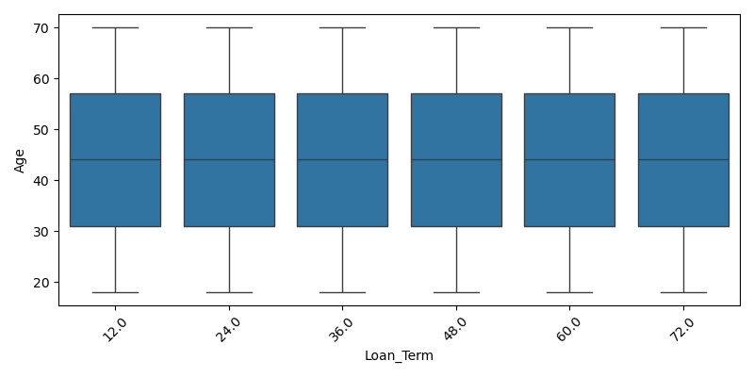

Annual_Income by Loan_Term
Group stats for numeric column 'Annual_Income' by category 'Loan_Term':
Loan_Term count mean median std
36 38266 1.350561e+06 1344075.5 664175.861035
72 27118 1.346008e+06 1345123.0 666500.072382
60 26902 1.347028e+06 1340376.5 660382.688961
12 26858 1.354554e+06 1362057.0 663044.167787
24 26775 1.347248e+06 1342822.0 666801.867999
48 23005 1.353664e+06 1354199.0 662525.746995
84 15199 1.341725e+06 1338512.0 662082.782297
240 9376 1.346874e+06 1350082.0 663670.996943
360 9310 1.346230e+06 1333203.0 661383.909041
120 9297 1.345510e+06 1345982.0 671919.452835
Plot:
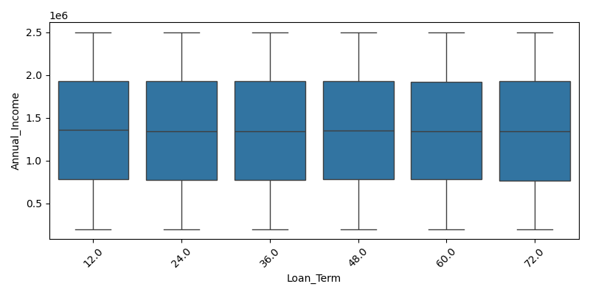

Loan_Amount by Loan_Term
Group stats for numeric column 'Loan_Amount' by category 'Loan_Term':
Loan_Term count mean median std
36 38266 7.128821e+05 645988.0 4.458864e+05
72 27118 7.870341e+05 703268.0 4.795617e+05
60 26902 7.873178e+05 700518.0 4.790586e+05
12 26858 5.379906e+05 536902.5 2.660152e+05
24 26775 5.413329e+05 542563.0 2.653775e+05
48 23005 8.126950e+05 723122.0 5.027995e+05
84 15199 5.513700e+05 553507.0 2.605578e+05
240 9376 2.737066e+06 2740500.5 1.300825e+06
360 9310 2.750696e+06 2750407.5 1.292179e+06
120 9297 2.729460e+06 2716895.0 1.299574e+06
Plot:
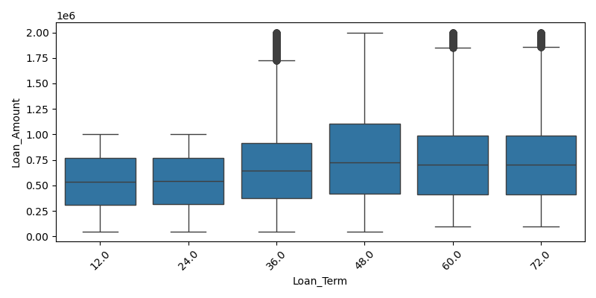

Credit_Score by Loan_Term
Group stats for numeric column 'Credit_Score' by category 'Loan_Term':
Loan_Term count mean median std
36 38266 575.561020 577.0 158.976520
72 27118 575.013902 575.0 159.081824
60 26902 576.116051 577.0 158.823987
12 26858 574.949549 574.0 159.203001
24 26775 573.459458 573.0 159.152539
48 23005 575.965399 576.0 158.430393
84 15199 574.578722 574.0 158.090798
240 9376 572.984962 574.0 159.086403
360 9310 576.305478 573.5 159.290615
120 9297 575.466495 575.0 158.179626
Plot:
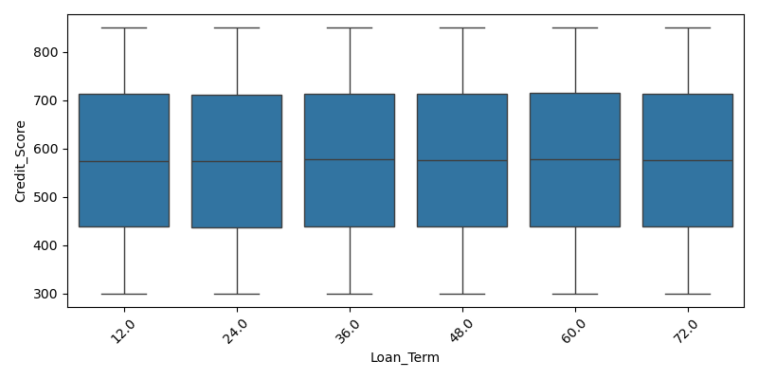

EMI_Amount by Loan_Term
Group stats for numeric column 'EMI_Amount' by category 'Loan_Term':
Loan_Term count mean median std
36 38266 23514.602581 21323.125 14727.929712
72 27118 15186.141166 13548.720 9299.841703
60 26902 17318.688509 15376.005 10576.416933
12 26858 47671.852553 47571.950 23576.290075
24 26775 25353.232520 25377.050 12441.846893
48 23005 21216.681169 18847.810 13168.293527
84 15199 9594.035098 9558.430 4578.578837
240 9376 29336.078017 28728.715 14602.497707
360 9310 27344.231483 26698.885 13720.867632
120 9297 38397.757755 38187.030 18637.313756
Plot:
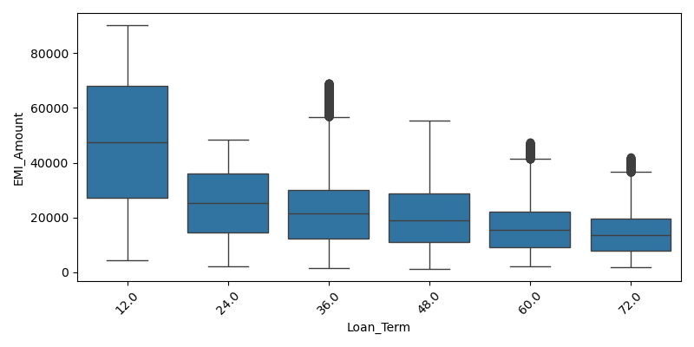

Mobile_Number by Loan_Term
Group stats for numeric column 'Mobile_Number' by category 'Loan_Term':
Loan_Term count mean median std
36 38266 2.945798e+11 7526118116.0 4.225974e+11
72 27118 2.964672e+11 7532795703.5 4.233235e+11
60 26902 2.997984e+11 7541792711.5 4.246214e+11
12 26858 2.961964e+11 7526118116.0 4.232899e+11
24 26775 2.982866e+11 7528757728.0 4.239237e+11
48 23005 2.996740e+11 7526118116.0 4.246288e+11
84 15199 2.905327e+11 7493137006.0 4.210571e+11
240 9376 3.022705e+11 7559967083.0 4.254841e+11
360 9310 2.997331e+11 7522950287.5 4.246766e+11
120 9297 2.866416e+11 7427033568.0 4.193803e+11
Plot:
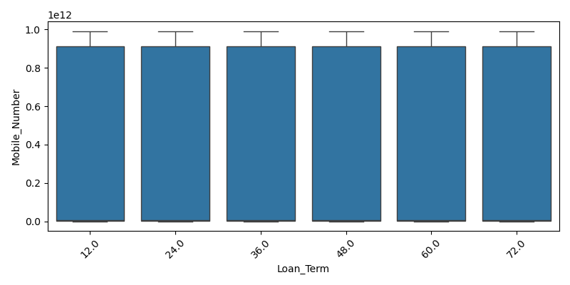

Age by Loan_Repayment_Status
Group stats for numeric column 'Age' by category 'Loan_Repayment_Status':
Loan_Repayment_Status count mean median std
COMPLETED 77227 44.097841 44.0 15.296323
PENDING 76641 43.990579 44.0 15.286076
DEFERRED 76616 43.943876 44.0 15.275750
Plot:
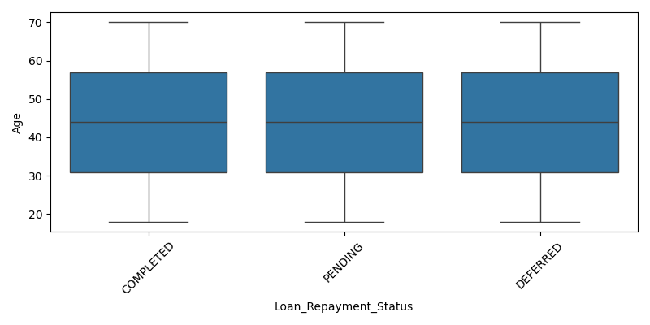

Annual_Income by Loan_Repayment_Status
Group stats for numeric column 'Annual_Income' by category 'Loan_Repayment_Status':
Loan_Repayment_Status count mean median std
COMPLETED 77227 1.350264e+06 1351336.0 663790.850448
PENDING 76641 1.344890e+06 1340116.0 664479.992424
DEFERRED 76616 1.351418e+06 1349510.5 664576.261348
Plot:
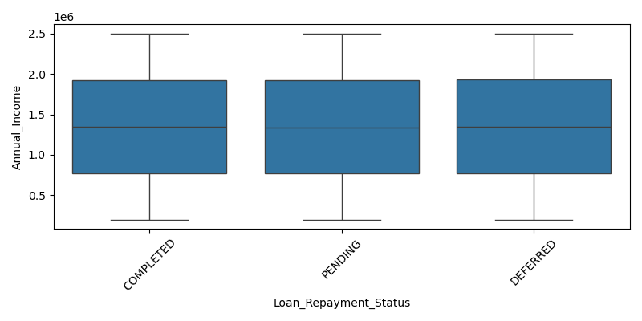

Loan_Amount by Loan_Repayment_Status
Group stats for numeric column 'Loan_Amount' by category 'Loan_Repayment_Status':
Loan_Repayment_Status count mean median std
COMPLETED 77227 1.098439e+06 741660.0 1.078008e+06
PENDING 76641 1.096458e+06 741015.0 1.080379e+06
DEFERRED 76616 1.098667e+06 741929.0 1.079739e+06
Plot:
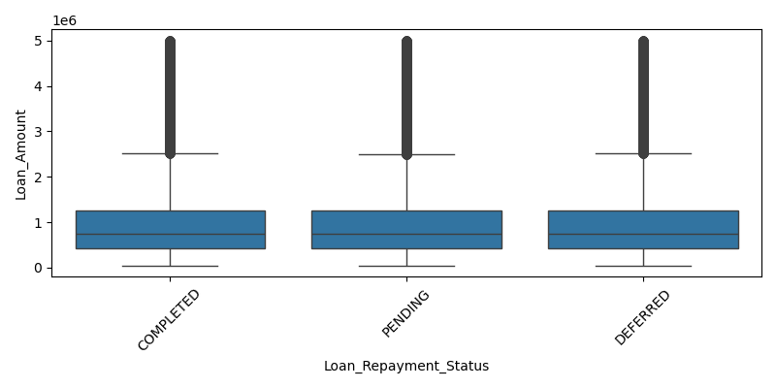

Credit_Score by Loan_Repayment_Status
Group stats for numeric column 'Credit_Score' by category 'Loan_Repayment_Status':
Loan_Repayment_Status count mean median std
COMPLETED 77227 574.924340 574.0 158.757943
PENDING 76641 575.783027 576.0 159.117710
DEFERRED 76616 574.713454 575.0 158.893504
Plot:
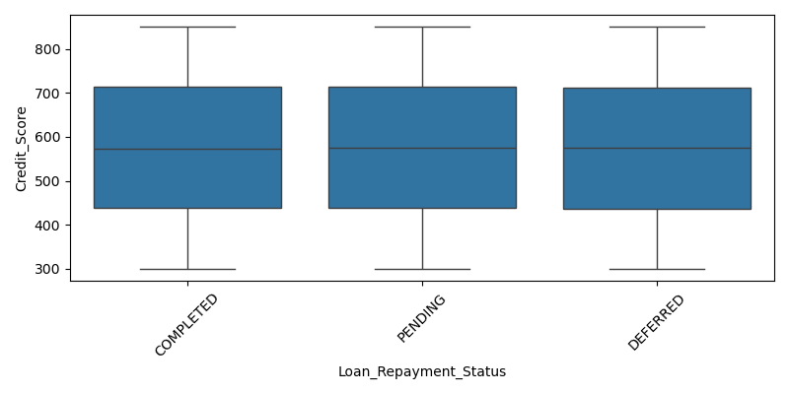

EMI_Amount by Loan_Repayment_Status
Group stats for numeric column 'EMI_Amount' by category 'Loan_Repayment_Status':
Loan_Repayment_Status count mean median std
COMPLETED 77227 25234.988267 20559.19 17738.402135
PENDING 76641 25196.962770 20559.20 17711.449621
DEFERRED 76616 25202.445451 20580.55 17776.703145
Plot:
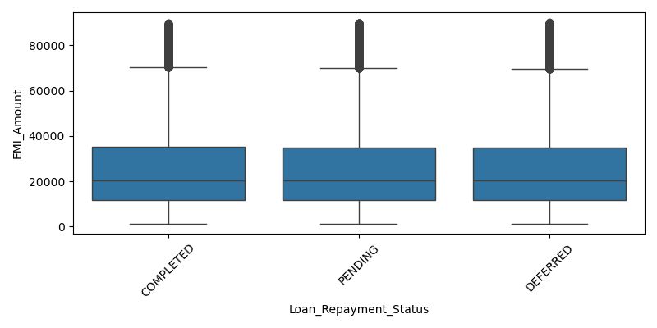

Mobile_Number by Loan_Repayment_Status
Group stats for numeric column 'Mobile_Number' by category 'Loan_Repayment_Status':
Loan_Repayment_Status count mean median std
COMPLETED 77227 2.957277e+11 7526118116.0 4.230018e+11
PENDING 76641 2.984151e+11 7526118116.0 4.240899e+11
DEFERRED 76616 2.962457e+11 7526118116.0 4.232957e+11
Plot:
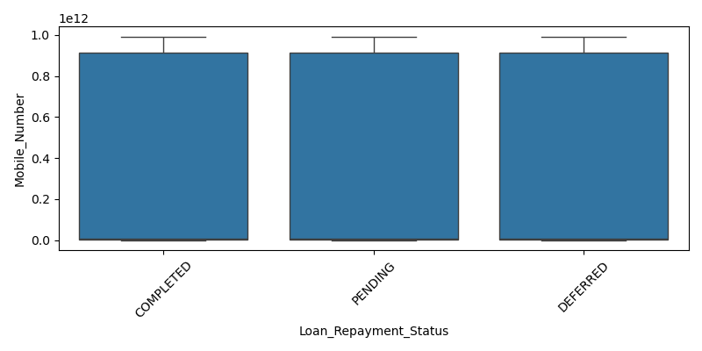

crosstab_Gender_vs_Loan_Status
Crosstab Gender x Loan_Status (top rows):
Loan_Status ACTIVE CLOSED DEFAULT
Gender
FEMALE 25378 25668 25698
MALE 25695 25816 25635
OTHER 25759 25465 25370
Plot:
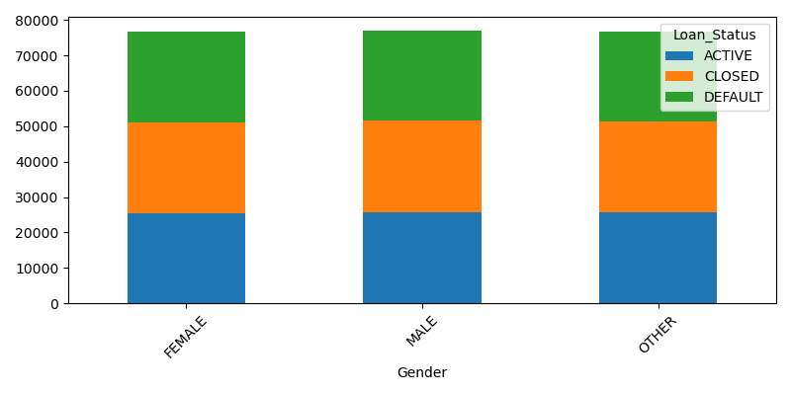

crosstab_Gender_vs_Loan_Term
Crosstab Gender x Loan_Term (top rows):
Loan_Term 12 24 36 48 60 72 84 120 180 240 300 360
Gender
FEMALE 9031 8959 12746 7579 8841 9094 5065 3006 3062 3150 3138 3073
MALE 9015 8942 12803 7700 8992 8980 5177 3136 3011 3147 3064 3179
OTHER 8812 8874 12717 7726 9069 9044 4957 3155 3064 3079 3039 3058
Plot:
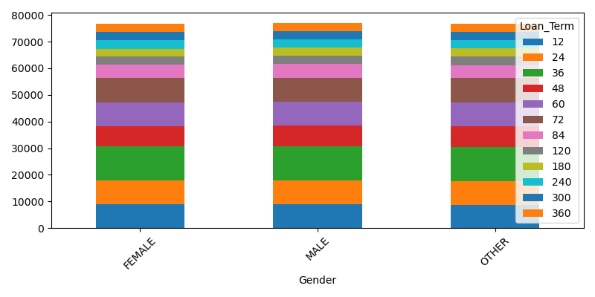

crosstab_Gender_vs_Loan_Repayment_Status
Crosstab Gender x Loan_Repayment_Status (top rows):
Loan_Repayment_Status COMPLETED DEFERRED PENDING
Gender
FEMALE 25640 25608 25496
MALE 25943 25564 25639
OTHER 25644 25444 25506
Plot:
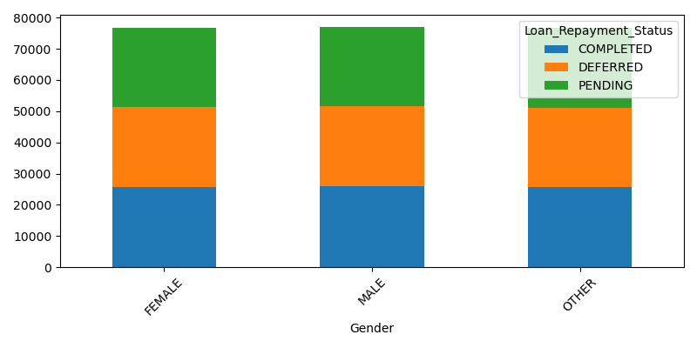

crosstab_Loan_Status_vs_Loan_Term
Crosstab Loan_Status x Loan_Term (top rows):
Loan_Term 12 24 36 48 60 72 84 120 180 240 300 360
Loan_Status
ACTIVE 8995 8939 12793 7664 8949 8903 5007 3095 3020 3166 3097 3204
CLOSED 8975 8936 13006 7630 8931 9085 5045 3062 3022 3084 3077 3096
DEFAULT 8888 8900 12467 7711 9022 9130 5147 3140 3095 3126 3067 3010
Plot:
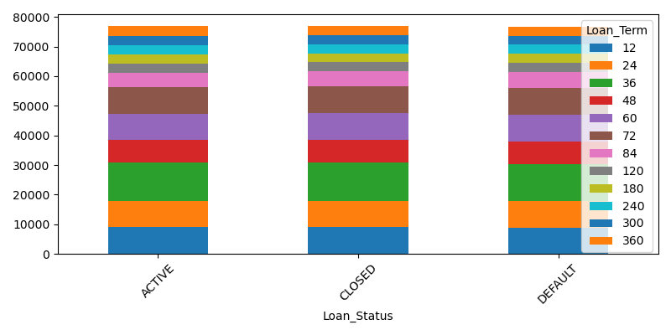

crosstab_Loan_Status_vs_Loan_Repayment_Status
Crosstab Loan_Status x Loan_Repayment_Status (top rows):
Loan_Repayment_Status COMPLETED DEFERRED PENDING
Loan_Status
ACTIVE 25582 25480 25770
CLOSED 25729 25593 25627
DEFAULT 25916 25543 25244
Plot:
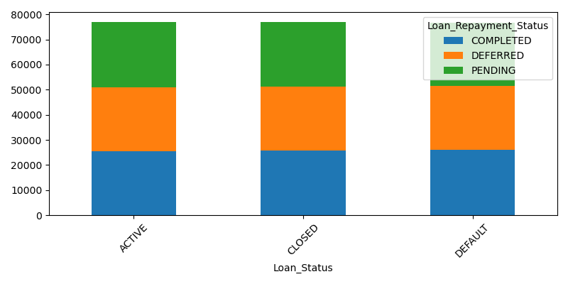

crosstab_Loan_Term_vs_Loan_Repayment_Status
Crosstab Loan_Term x Loan_Repayment_Status (top rows):
Loan_Repayment_Status COMPLETED DEFERRED PENDING
Loan_Term
12 9073 8803 8982
24 8787 9006 8982
36 12831 12756 12679
48 7770 7588 7647
60 9005 8934 8963
72 9154 9030 8934
84 5075 5062 5062
120 3128 3068 3101
180 3129 3044 2964
240 3109 3181 3086
Plot:
